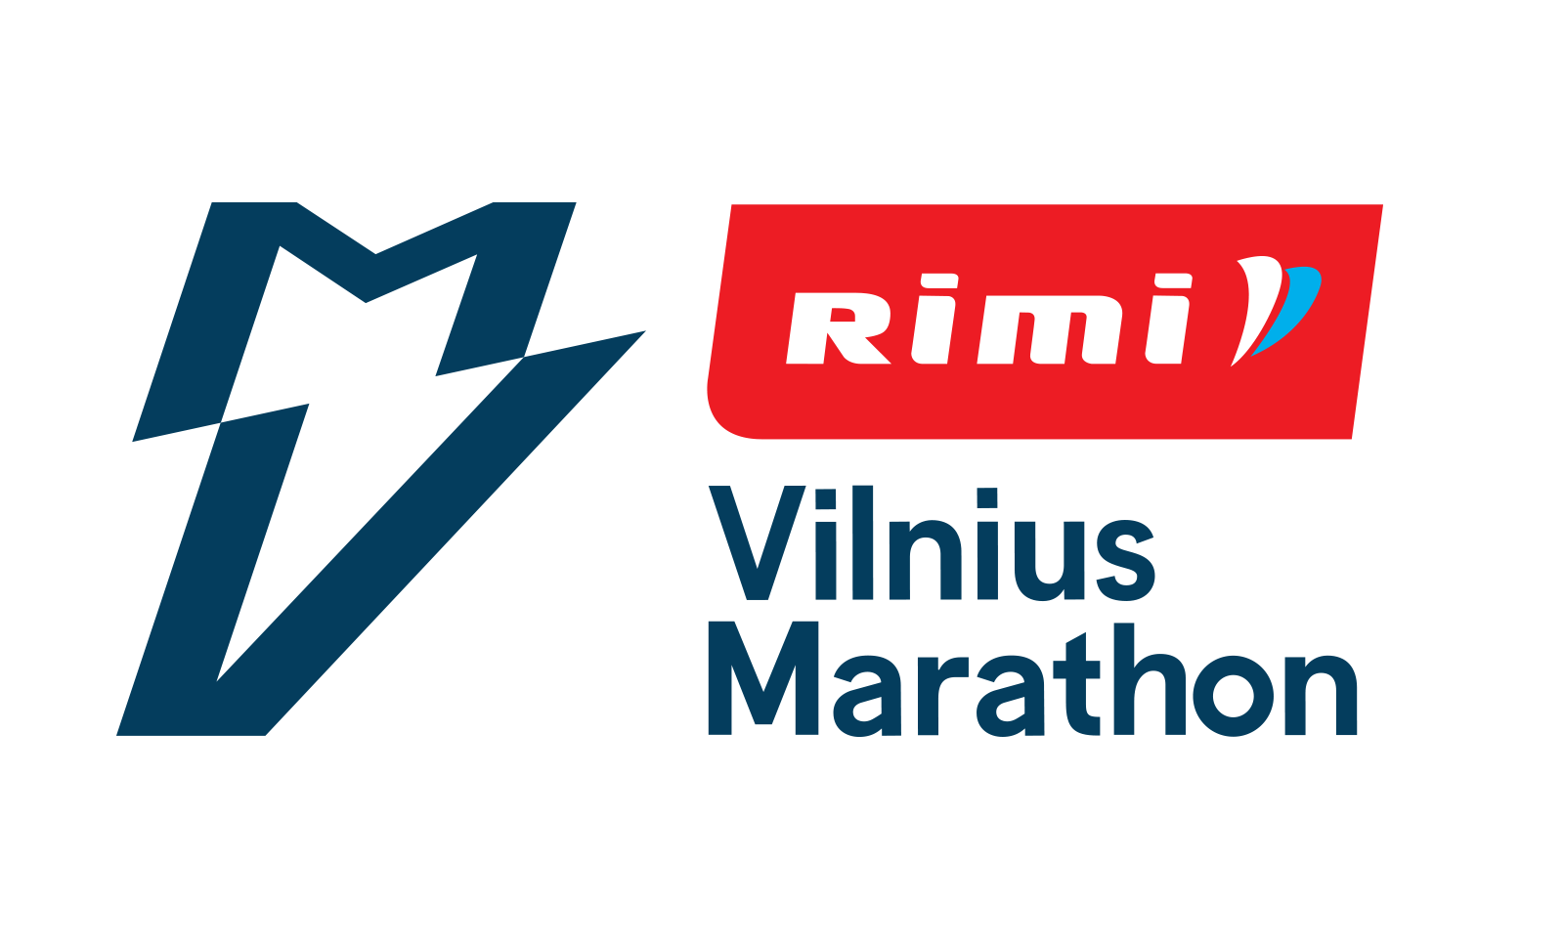

For RIMI VILNIAUS MARATHON organizers

Consent

I, |  |  | ,
 | ^{name and surname} |  |  |  | ^{date of birth}
agree that my minor |  | son / daughter
 |  | ^{cross out unnecessary}
 |  |  | ,
^{name and surname} |  |  |  |  | ^{date of birth}

participates in Rimi Vilnius Marathon on September 12th, 2021 and I take full responsibility for my child's health and participation in this event. I have met the rules of the event and I agree with them unconditionally.

 | ,
^{name and surname} |  | ^{signature}

Date:

Official Rimi Vilnius Marathon Website and Event Rules: www.vilniausmaratonas.lt

This consent must be provided at the time of picking up the start numbers.

